西安瑞禧生物科技有限公司

Certificate of Analysis

General properties:
Name：Fmoc-PEG-COOH ,MW:2000
Molecular Weight: 2000Dalton
Cat.#: R-1116
Lot.#: 1598812
Manufacture Date: 2015.10.14
Date of Analysis: 2015.10.14
Recommended Retest date: 2016.10.14
Stability: 12 months
Storage: -20°C in the dark

Structure

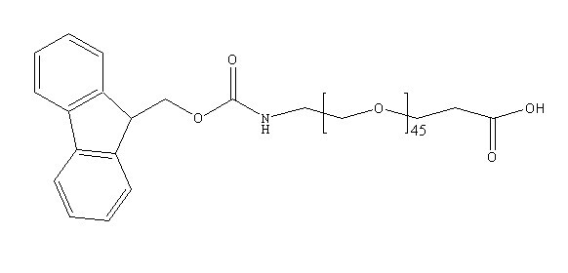
Items | Specification | Results
Appearance | White/ Off-white solid | Off-white solid
¹H NMR | Identical to the structure | Identical to the structure
Foreign Material | None | None
Substitution | ＞90% | 95%
Report Date: 2015.10.14

This product is for research use only, Not for human or animal use

Xi'an ruixi Biological Technology Co., Ltd Web:http://www.xarxbio.com
Xi'an city ,Shaanxi Province, China http://www.resenbio.com
Tel: 0086 29 86354885 E-mail:sales@xarxbio.com

